**DAILY ONLINE ACTIVITIES SUMMARY**

|  |  |  |  |  |  |  |  |  |
| --- | --- | --- | --- | --- | --- | --- | --- | --- |
| **Date:** | **23-5-2020** | | | | | **Name:** | **poojashree** | |
| **Sem & Sec** | **8th sem A sec** | | | | | **USN:** | **4al16cs065** | |
| **Online Test Summary** | | | | | | | | |
| **Subject** | |  | | | | | | |
| **Max. Marks** | |  | | **Score** | | |  | |
| **Certification Course Summary** | | | | | | | | |
| **Course** | **Introduction to ethical hacking** | | | | | | | |
| **Certificate Provider** | | | **Great learning academy** | | **Duration** | | | **6.5hr** |
| **Coding Challenges** | | | | | | | | |
| **Problem Statement:** 1.**Write a python program to find ith element**  **2.write a python program to count positive and negative element in the list** | | | | | | | | |
| **Status:completed** | | | | | | | | |
| **Uploaded the report in Github** | | | | | **yes** | | | |
| **If yes Repository name** | | | | | **Poojashree** | | | |
| **Uploaded the report in slack** | | | | | **yes** | | | |

**Online test**

**--------------------Not there-----------------------**

**Certification course**

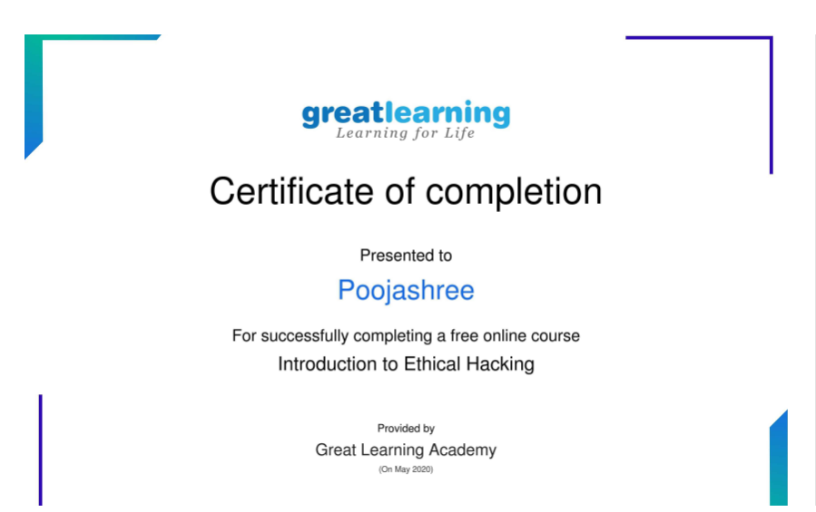

Coding

**Program 1**Top of Form

Bottom of Form

Top of Form

Bottom of Form

Top of Form

Bottom of Form

Top of Form

Bottom of Form

|  |  |
| --- | --- |
|  | #remove ith element |
|  | def remove(string, i): |
|  |  |
|  | for j in range(len(string)): |
|  | if j == i: |
|  | string = string.replace(string[i], "", 1) |
|  | return string |
|  |  |
|  |  |
|  | if __name__ == '__main__': |
|  |  |
|  | string = "geeksFORgeeks" |
|  | i = 5 |
|  | print(remove(string, i)) |

**Program 2**

|  |
| --- |
|  |
|  | list1 = [10, -21, 4, -45, 66, -93, 1] |
|  | pos_count, neg_count = 0, 0 |
|  |  |
|  |  |
|  | for num in list1: |
|  |  |
|  |  |
|  | if num >= 0: |
|  | pos_count += 1 |
|  |  |
|  | else: |
|  | neg_count += 1 |
|  |  |
|  | print("Positive numbers in the list: ", pos_count) |
|  | print("Negative numbers in the list: ", neg_count) |